B&B Volleyball
P.O. Box 409
East Meadow, NY 11554
Email: bb@bbvolleyball.com
www.bbvolleyball.com
516-732-2544
B&B Volleyball Junior’s Indoor Pre-Tryout Clinic
B&B Volleyball will be holding a 3 day Junior’s Indoor Pre-Tryout Clinic prior to upcoming Club and/or School Try-outs. This clinic is designed to get athletes ready to perform their best at tryouts, as well as show those who attend what B&B Volleyball is all about.
When: Friday, August 18th from 5:30 - 9:30pm
Saturday, August 19th from 10am - 2pm
Sunday, August 20th from 10am - 2pm
Location: Green Vale School – 250 Valentines Lane, Glen Head, NY 11545
Cost: $295/player Please Register by: Friday, August 11, 2017
Our pre-tryout clinics will focus on preparing players for their upcoming club/school tryout with special focus on technical development, quality repetition, and tryout plan readiness, as well as special review of basic and advanced volleyball skills such as, but not limited to:
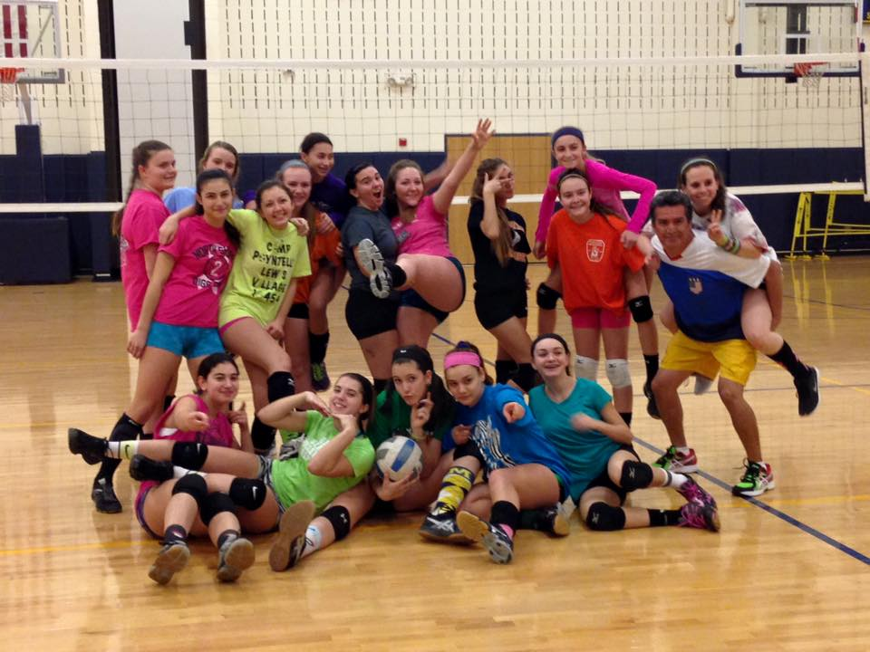
- Serving
- Spiking
- Blocking
- Setting
- Defense (Libero)
- Serve-Receive
Our B&B Volleyball Junior’s Indoor Pre-Tryout Clinic is a great opportunity for players to be seen by the prospective coaches prior to club tryouts. Our Club Directors and Coaches will be present to coach and evaluate players. We want to make sure the pre-tryout clinic process helps select the best players for each team. We know tryouts are stressful and want to give players multiple opportunities to be seen as well as help them perform well at tryouts!
B&B Volleyball
P.O. Box 409
East Meadow, NY 11554
Email: bb@bbvolleyball.com
www.bbvolleyball.com
516-732-2544
B&B Volleyball Junior’s Indoor Pre-Tryout Clinic
Registration Form
When: Friday, August 18th from 5:30 - 9:30pm
Saturday, August 19th from 10am - 2pm
Sunday, August 20th from 10am - 2pm
Location: Green Vale School – 250 Valentines Lane, Glen Head, NY 11545
Cost: $295/player Please Register by: Friday, August 11, 2017
Please Pre-Register by emailing bb@bbvolleyball.com and promptly send Registration Form and Payment to: B&B Volleyball
P.O. Box 409
East Meadow, NY 11554
Cash or checks accepted – Please make checks payable to: B&B Volleyball
--------------------------------------------------------------------------------------------------------------
PLAYER NAME: ________________________________ DATE OF BIRTH: _____________ AGE: _____________
HEIGHT: _________________ POSITION: ____________________________ RIGHTY/LEFTY __________________
2016-2017 CLUB & TEAM NAME: ________________________ 2017 SCHOOL TEAM: _____________________
ADDRESS: ______________________________________________________________________________________
PARENT NAME(S): ________________________________ PHONE (Home/Cell):___________________________
EMAIL ADDRESS: _________________________________________________________________________________
For Questions:
Email: bb@bbvolleyball.com
Call: Coach Keith Burt at 516-428-8990 / Coach Mike Brewer at 516-732-2544
Visit us at: www.bbvolleyball.com

