B&B Juniors Beach Doubles Volleyball Club
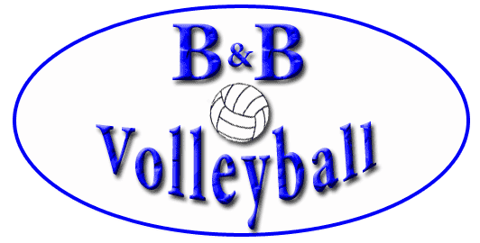

Registration Form
******************************************************************************************
Player Name: _______________________________________ Date of Birth: ____________________________
Address: __________________________________________________________________________________
Email Address: ______________________________________ Phone Number: ___________________________
Emergency Contact – Name: ____________________________ Phone Number: __________________________
Shirt Size (Adult Sizes): ________________________________ Preferred Jersey Number: __________________
******************************************************************************************
Fees: $695/player B & B 2016-2017 indoor club members: $620/player
*$300 non-refundable deposit due with registration by MAY 15, 2017
Please Check One:
Joining with a Partner: _____________ Partner Name: ___________________________________
(Partner must also complete registration form)
Joining as an individual:_____________
How did you hear about our Club (Referred by?): ___________________________________________________
******************************************************************************************
All Players must be Paid in Full by: JUNE 1, 2017
Make Checks Payable to: B&B Volleyball
Mail to: B&B Volleyball, P.O. Box 409, East Meadow, NY 11554
B&B Volleyball
516-732-2544
www.bbvolleyball.com
Email: bb@bbvolleyball.com
Like us on Facebook! www.facebook.com/BBVolleyball
B&B Juniors Beach Doubles Volleyball Club

Additional Apparel

NAME: ________________________________________

Vincere Sand Socks (included with registration)

(CHECK ONE)
____ XXS (W3-5.5)
____ XS (W5.5-7)
____ S (W6.5-8.5)
____ M (W 9-11.5)
____ L (W12.5-14)
____ XL (W14+)
____ XXL (W14.5+)

Optional B & B Volleyball bikini top/bottom (Fill this section out if opting to purchase )

_____ Nike Bikini Top
(check) Color - Deep Night Magenta
Approx $25

Sizes(Circle one): XS S M L XL

*****

_____ Bathing Suit Bottom with Logo
(check) Choice of Bikini or Boy Short
Approx $20-25

Sizes(Circle one): XS S M L XL XXL

